UNIVERSITY OF THE WITWATERSRAND, JOHANNESBURG
SCHOOL OF ELECTRICAL AND INFORMATION
ENGINEERING

ELEN 7046: Software Technologies and Methodologies

Asset Tracker System
03-July-2017
Group 4

Group Members:
Mashudu Maranda - 0609311K
Phuti Rapheeha - 1558689
Setjhaba Koloti - 1271865
Shadrack Nekuvhi - 337217

Declaration
Table 1. Discretionary Marks
Group Member | Primary Task | Time Spent (Hours) | Discretionary Marks (25%)
Mashudu Maranda | Requirements Elicitation  User Interface (UI) | 105 | 6.00%
Phuti Rapheeha | Requirements Elicitation  Batch Layer  Servicing Layer  Persistence | 100 | 6.00%
Setjhaba Koloti | Requirements Elicitation  Speed Layer  WebSocket Layer | 107 | 6.00%
Shadrack Nekuvhi | Requirements Elicitation  RESTful Web Service | 80 | 2.00%

Table 1 outlines discretionary marks allocation and time spent by each group member on the assigned tasks.

- Mashudu Maranda

Signature: _________________ Date: __________________

- Phuti Rapheeha

Signature: _________________ Date: __________________

- Setjhaba Koloti

Signature: _________________ Date: __________________

- Shadrack Nekuvhi

Signature: _________________ Date: __________________

Abstract
Processing real-time data streams could be done using different techniques. This report presents the Asset Tracker Solution to process real-time GPS (Global Positioning System) data streams. Asset Tracker System is built using Lambda Architecture techniques. Lambda Architecture enables real-time data streams to be processed in two ways and served to to the consumers or client applications from one central location. The gives a critical discussion on Particle IoT (Internet of Things) devices, that are used as source of data for the Asset Tracker System. The report also discusses the Services API (Application Programming Interface) using WebSocket and REST technologies, and the front-end technologies used to implement User Interface (UI) to visualise data to the users.

Contents
1 Introduction 1

2 Background 1
2.1 Real-time Viewing 2
2.2 Batch Processing 2
2.3 Historical Patterns 2
2.4 Hotspot Notification 2
2.5 Persistence 2

3 Project Management 3
3.1 Methodology 3
3.2 Project Plan 3
3.3 Task Management 4
3.4 Challenges 4
3.4.1 The Learning Curve 4
3.4.2 Limited Documentation on new Technologies 4
3.4.3 Availability of Project Team Members 5

4 Development Tools 5
4.1 Spark 5
4.2 Angular 2+ 6
4.3 Scala 6
4.4 TypeScript 6
4.5 IntelliJ IDE (Integrated Development Environment) 6
4.6 Kafka 7
4.7 Zookeeper 7
4.8 Cassandra Database 7
4.9 Visual Studio Code 7

5 Overview of Design 8
5.1 Lambda Architecture 8
5.2 System Architecture 8
5.2.1 Particle Device 9
5.2.2 Batch Layer 10
5.2.3 Speed Layer 11
5.2.4 Serving Layer 11
5.2.5 Persistence 11
5.2.6 WebSocket Server 12
5.2.7 RESTful Service 13
5.2.8 User Interface (UI) 13
5.2.8.1 Services 14
5.2.8.2 Components 14

Conclusion 15

References 16

Introduction

Background
The Assert Tracker System results from an investigation of how an IoT device that provides GPS coordinates can be used to develop a software solution. The system is centered around management of such devices, and the use of them to track locations of assets by owners. The nature of these requirements present a Big Data challenge, as data needs to be collected at any given time and historical data should be able to be analysed so that future predictions and emerging behavior patterns in the movements or lack thereof of the assets can be identified.

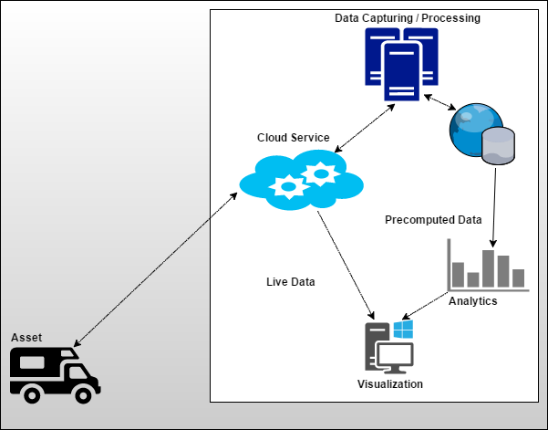
Figure 1. Asset Tracker System - Conceptual Design
The Asset Tracker System not only aims to provide a live tracking feature, but also provide the asset owners with the ability to gain insight so that they may be able to make informed decisions on their assets. Figure 1 illustrates the solution proposed for the Asset Tracker systems, and how device tracking data is collected and channelled through different aspects of the system for further processing.

Real-time Viewing
The Asset Tracker is required to have a real-time feature, where the current location of an asset needs to be viewable by the owner at any given time. This should also include reflection of the asset when in motion. The data that is being collected from the asset’s location should be stored into a database.

Batch Processing
While real-time data is being collected, there needs be another feature to collect data in batches, where specific computing is performed prior to the data being persistent into the database. The precomputed data becomes part of the analysis view in combination with the live stream.

Historical Patterns
The owner should be able to view historical locations of an asset for any given period. Data should be able to be analysed to identify any patterns from the historical data, and can predict future behaviours or locations based on the trends shown by the historical data in combination with the live data that is coming in.

Hotspot Notification
For any given asset, the owner should be able to mark any areas by provision of set of coordinates to label as hotspots. If the asset moves into the vicinity of a hotspot, the user should be able to receive notification of that. This will allow the owner to know when the asset when an asset is in an undesirable or even desirable.

Persistence
All data that is received should be persisted into a database so that it can be later retrieved for further future analysis. The system should be able to also persist pre-calculated data into the database to reflect the understanding or requirements of the system at the time the asset was at a location.

Project Management

Methodology
Given the timelines, logistics and availability of the group members, it was decided that we adopt the Agile Kanban methodology. Initially, the group had intended to adopt the Scrum methodology, however, the nature of the timelines, and the prescription of Scrum for daily standups, it proved a difficult endeavor to adopt Scrum. The Kanban methodology still allowed the team to be able to breakdown the endeavor into small sections of workable items, and log them into the project backlog.
Items were continually monitored, and moved across the Kanban board swim-lane of work processes. This provided the team with the ability to have a visual aspect of what work is being done, and also be able to identify what work is planned to be completed, and also the outstanding.

Project Plan
The project was completed with 5 sprints, 20 user stories and 7 spike or investigation tasks. One user story to analyse the crime hot spots was not completed due to time constraints and the project team decided to include this feature in Phase II of the project. Table 2 depicts user stories completed and their respective sprints.
Table 2. User Stories Completed
User  Story | Story Points | Sprint Number | Sprint  Boundary
Particle device setup | 13 | 1 | 20-Apr to 04-May
Log data into CSV files | 8 | 1 | 04-May to 17-May
Requirements gathering | 8 | 1 | 20-Apr to 04-May
Mongo database Investigation (Spike) | 0 | 1 | 20-Apr to 03-May
Scala Investigation (Spike) | 0 | 2 | 04-May to 17-May
Lambda Architecture Investigation (Spike) | 0 | 2 | 04-May to 17-May
Kafka Investigation (Spike) | 0 | 2 | 04-May to 17-May
Akka Investigation (Spike) | 0 | 2 | 04-May to 17-May
Spark Investigation (Spike) | 0 | 2 | 04-May to 17-May
Play Framework Investigation (Spike) | 0 | 5 | 15-Jun to 27 Jun
Setup Development Environment | 13 | 3 | 18-May to 31-May
Create Event Producer | 13 | 3 | 18-May to 31-May
Create Event Streaming Job | 8 | 4 | 01-Jun to 14-Jun
Create Event Batch Job | 13 | 4 | 01-Jun to 14-Jun
Persist data to Cassandra database | 5 | 6 | 15-Jun to 27 June
Create WebSocket Server | 13 | 6 | 15-Jun to 27 June

Task Management
The endeavour presented to the team a lot of challenges to learn new technologies and languages. In the initial phases, it proved a difficult attempt to assign specific tasks to team members. Ultimately, members were required to nominate themselves on which tasks they wish to take on. As the project progressed, it became a lot easier to identify member’s strengths in relation to different system components.
Most the work in for the can be categorize as follows:
- The Batch Layer
- The Speed Layer
- The Serving Layer
- Services
- The User Interface

Challenges

The Learning Curve
The group had opted to look to use technologies that they are unfamiliar with, as prescribed in the course description. Most notably, the technologies chosen presented a steep learning curve. The paradigms were unfamiliar to most of the group members. However, in the end much progress was made in this regard, and as soon as the steep learning curve was overcome, progress began to come in thick and fast.

Limited Documentation on new Technologies
In addition to the learning curve, many of the technologies chosen have not developed across large communities, therefore, there are several critical libraries that are used that have few documentations.

Availability of Project Team Members
Availability of members over weekends or outside working hours has been a serious challenge because of logistics. Members reside in different areas, have different working hours and have different commitments outside working hours. The group used WhatsApp a lot of times for communications and planning. The advantage that this provided was that ad-hoc meeting could be quickly arranged when members were available.

Development Tools

Spark
Spark is a powerful, fast data processing engine that runs on Hadoop. Spark is compatible with various Hadoop systems such as Cassandra, Hive, HBase, etc. It is used for processing large amounts of data across clusters. Spark can also run on a single node. Spark provides several libraries that are aimed at big data processing, such as:
- SparkSQL
- Spark Streaming
- MLLib (Machine Learning Library)
- GraphX

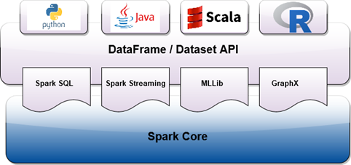
Figure 2. Spark Streaming Platform
The group has chosen to use Spark as an option among similar technologies such as Storm, with the reasons that Spark can be used in several languages as an option, namely Python, Java, Scala, and R; as shown in Figure 2.

Angular 2+
Is an open source framework for developing user interfaces which run on a browser on any platform, this support TypeScript and bring portability advantages and hides the complexity of JavaScript. The group chose Angular 2+ as it manages streamed data efficiently using observables. Angular CLI makes development of angular application much more easy and create program structure based on best practises[8].

Scala
Scala is a functional programming language that can be use interoperable with Java. Scala runs on a Java Virtual Machine (JVM), providing the advantage of seamless transition from Java development to Scala[1]. Scala also gives the advantage that Java libraries can also be used within the Scala platform to cater for cases that may be challenging to tackle using Scala.

TypeScript
“TypeScript is a typed superset of JavaScript that compiles to plain JavaScript[6]”, it’s syntax is close to the conventional Java and C# which made it easy for the team to adapt and giving us the benefit of hiding the complexity of JavaScript. TypeScript runs on any web-browser, any host and any OS, which complements our technology stack as it runs on any platform.

IntelliJ IDE (Integrated Development Environment)
IntelliJ IDE Community has been selected as the IDE of choice as it was found to be easier to learn and use. The IDE uses a Maven Plugin that allows for better grouping of different sections of the code, giving the solution a structure that can be easily navigated through. The IDE also allows for easy specification of 3rd party libraries that are used in the system, and can automatically download additional plugins.

Kafka
Kafka is a distributed streaming platform that provides systems with messaging capabilities. However, Kafka is not as traditional messaging systems that queues and pushes out messages. Instead, Kafka works on a publish/subscribe functionality, whereby systems interested in the messages subscribe to Kafka topics[14]. Messages that pushed into Kafka are broadcast to interested listeners/subscribers, but they are not pushed or discarded as in queueing systems.

Zookeeper
Zookeeper is chosen as a centralized service that maintains configurations and naming across a distributed system. In the context of the Asset Tracker, Zookeeper is used to control synchronization between Kafka nodes where multiple nodes are employed.

Cassandra Database
Cassandra database has been chosen since it’s a distributed storage system which can store large amounts of data. It has high availability service with no single point for failure[4]. It allows query usage by making use of key-value model, with unique row key. It is a NoSQL database[18]. The advantage of Cassandra is that it uses commit- log based persistence design. It also comes with tunability levels of durability. It is also important if you need system with durable and performant data store[5].

Visual Studio Code
Visual Studio Code is a new editor from Microsoft that support debugging, embedded Git source control, intelligent code completion, and code refactoring which also helped in reducing complexity as some members had little to no experience of Git. Visual Studio Code is free and makes development of Angular 2+ projects much easy.

Overview of Design

Lambda Architecture
Given the nature of the solution of Asset Tracker, Lambda architecture has been identified as a suitable approach. Lambda Architecture aims to satisfy the requirement for reacting to newer data with great speed, while also being able to provide analysis of the older data in combination with the new incoming data. Lambda Architecture specifies the following layers to address use such use cases:
- The Speed layer
- The Batch layer
- The Serving layer

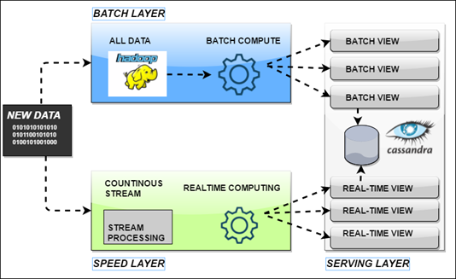
Figure 3. Lambda Architecture, Adapted from[12].
Figure 3 demonstrates the structure of a lambda architecture approach. Each layer is discussed in the next sections.

System Architecture
Figure 4 depicts all logical components of the Asset Tracker Solution and flow of information.
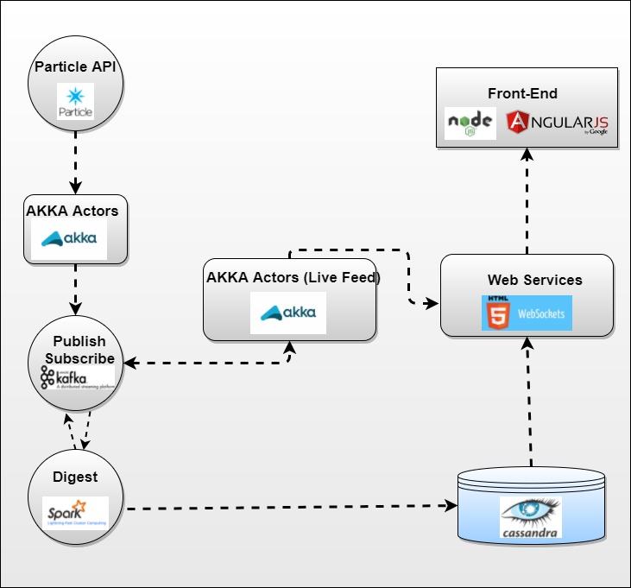
Figure 4. Asset Tracker Solution - Logical Design
Data Ingest gets raw JSON (JavaScript Object Notation) data stream from the Particle cloud using Akka HTTP that supports SSE (Server-Sent Event) and pushes data stream to Kafka. Data Processing is streaming platform where raw data stream is processed and transformed using Spark Streaming. The transformed data is persisted to Cassandra and then pushed to Kafka.

The WebSocket Server uses Akka Actors to consume transformed data stream from Kafka and exposes a WebSocket endpoint API to the UI for real-time visualisation. The REST Web API exposes RESTful endpoint for queries that are run against Cassandra data required for visualising historical data on the UI.

Particle Device
Particle device used in this project cantered around of two modular components, namely Particle Electron with 2G and Particle GPS Asset Tracker. Particle Electron allows IoT devices like GPS Asset Tracker to connect to the web with cellular connection. It is optimized to use less bandwidth data and it has fully integrated hardware that connects to the Particle cloud using cellular network[11].

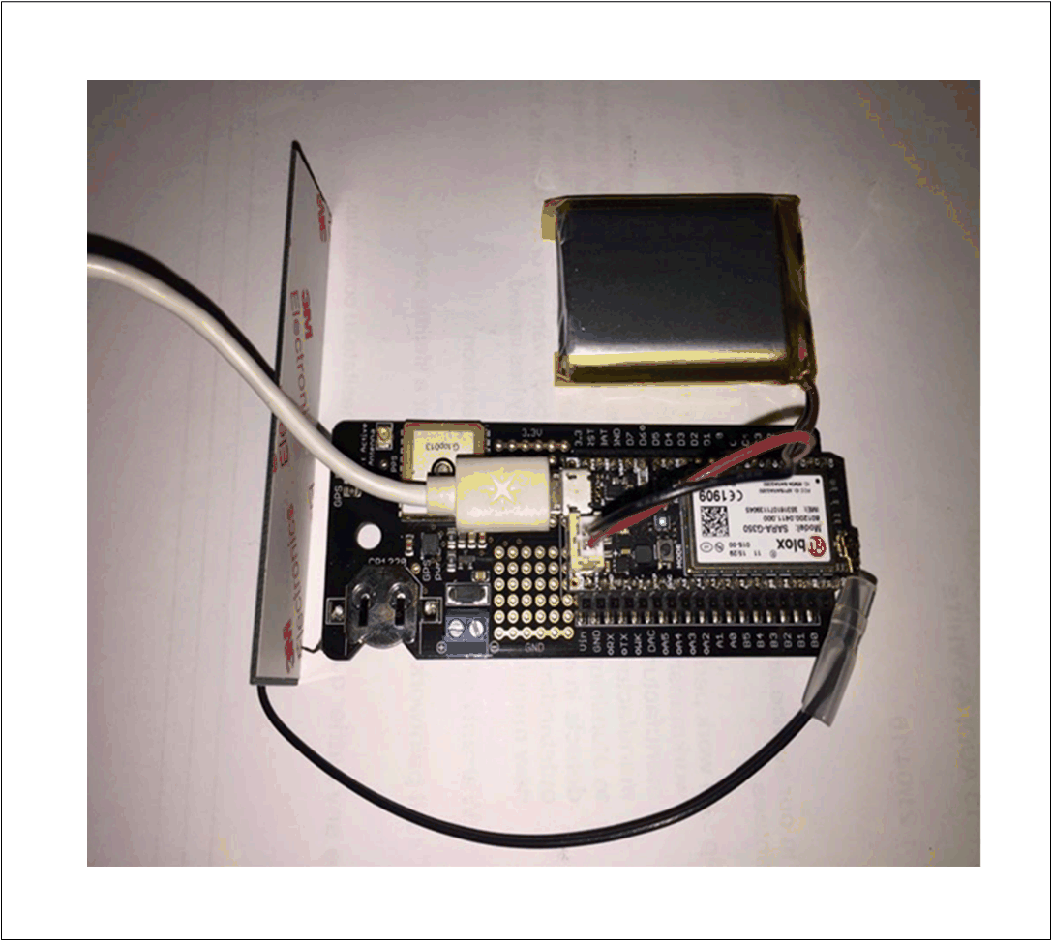
Figure 5. Particle Electron with Asset Tracker Device
Particle GPS Asset Tracker is a component that is built to emit GPS coordinates and can integrate with Electron device to send data to the Particle cloud. Figure 5 depicts Electron and GPS Asset Tracker integrated into consolidated unit.

Batch Layer
The batch layer is intended to precompute large amount of data and then persist the results into the database. The batch layer computes on available data, and can recalculate existing data in combination with the new incoming data, and update rewrite the newer results into the database. This means that with more results coming in, the batch layer achieves greater result accuracy with the growth of available data.

Speed Layer
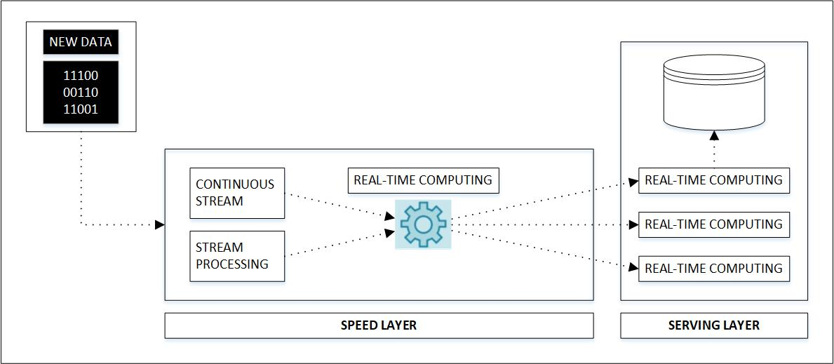
Figure 6. Lambda Architecture - Speed Layer, Adapted from[12].
Lambda Architecture’s speed layer addresses the latency of the batch layer, where the data streams through. The speed layer is temporal in nature, that means it can only keep data in its memory for a certain time and clears it to make room for the new increments of data. As much as the speed layer is fast, accuracy of the data is questionable because of its temporal nature characteristics[12]. However, the data accuracy gap is closed by a batch layer that processes data in chunks at its own pace, or low latency at the same guaranteeing data accuracy. The speed layer also presents its portion of the transformed data to the serving layer where data get persisted and presented to the users, as illustrated in Figure 6.

Serving Layer
The serving layer serves as a layer that provides a combination of both the speed and batch layer together. These results are stored in a Cassandra database. The serving layer serves the client application with the aggregated results. The serving layer does not write any data into the database, and is typically executing in read-only mode.

Persistence
“Persistence is the continuance of an effect after its cause is removed. In the context of storing data in a computer system, this means that the data survives after the process with which it was created has ended[3]”.
A Scala method is implemented to collect all elements in the RDD (Resilient Distributed Dataset). Elements are grouped in a batch statement, to be sent to Cassandra database Saving some latency. This is to avoid persisting one record at a time, which is inefficient. The Spark-Cassandra-Connector is used to persist data from Spark into Cassandra. It’s easy to use and avoids a good amount of boilerplate code.

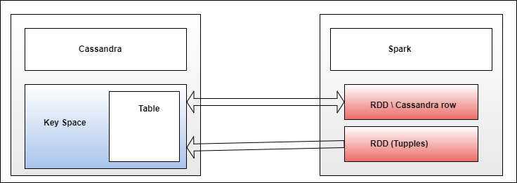
Figure 7. Spark-Cassandra Integration, Adapted from[9].
Figure 7 above shows how Cassandra and Spark works together. The connector send or reads information to and from Spark RDDs.
The Spark-Cassandra-Connector helps with[10]:
- Bulk writing to Cassandra
- Distributed full table scans
- Optimised direct joins with Cassandra
- Secondary Index Push Down.
- Connection and prepared statement pools

WebSocket Server
WebSocket offers functionality full duplex bidirectional communication between web servers and clients[16][17]. This technology works very with real-time solution visualisation spatial data to the UI, because of its capability that allows users to start connection to the server and the server providing incremental streams of data using the connection until the client or server terminates a connection.
The WebSocket server is implemented on Play Framework’s MVC (Model-View-Controller) and Web API platform with Akka Actors for reactive streams coming from Kafka. The WebSocket server is responsible for consuming transformed data stream from Kafka’s topic and feeds it the HTTP clients for real-time data visualisation[13][14][15].

RESTful Service
RESTFul service is used to expose data saved into Cassandra database and this data is passed to the front-end (Angular 2). Data is exposed in JSON format. The controller is used to enable view on JSON format. This enables developers to make sure that HTTP verb and endpoint are matched.
“Play is a stateless, asynchronous, and non-blocking framework that uses an underlying fork-join thread pool to do work stealing for network operations, and can Leverage Akka for user level operations”. “Play Framework makes it easy to build web Applications. Has a built-in JSON module and extensive NoSQL & Big Data Support[19]”.

User Interface (UI)
The User Interface is a web-based application that can be accessed from any platform which makes it flexible and usable to different kinds of users, it is used to view Live data and historical or persisted data.
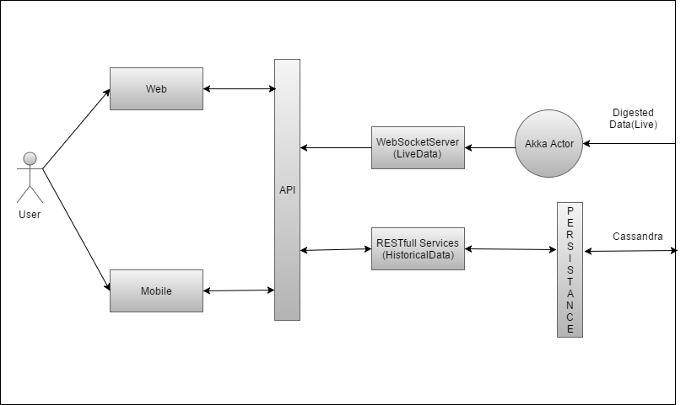
Figure 8. Service Architecture for Play Framework
Figure 8 shows how Play Framework is adopted to develop the services and view[7]. Live data is streamed using WebSocket Server with the UI using Observable services to connect to the WebSocket Server, which enforces that the UI is always aware of the new data coming in from the WebSocket Server. Historical/Persisted data is served using RESTful services and data from the UI is also persisted through the RESTful services.
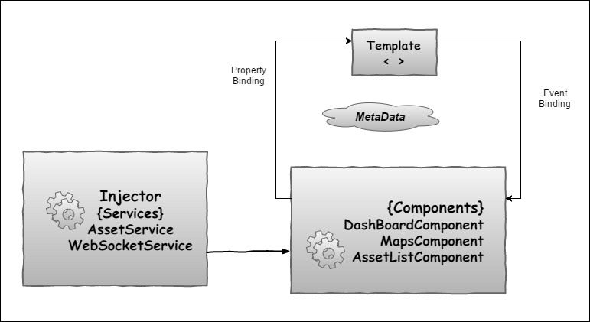
Figure 9. User Interface Architecture
The UI follows the standard program structure of Angular 2+, which separates components or modules. The services can be injected to any component making them shared services, which binds the components and templates using properties or events based on the action, as depicted in Figure 9.

Services
The Asset Tracker System consists of the following two UI services:
- AssetService includes that of getting historical data and sending data to be persisted.
- WebSocketService serves the UI with live stream data.

Components
The Asset Tracker System consists of the following three UI Components:
- DashBoardComponent present a summary of asset(s) added to the specific user’s board.
- MapsComponent present asset(s) position or location on the map, which also show all hotspots based on how they are set by the user.
- AssetListComponent is basically used to show a list of assets that are linked to a specific user and adding the list to the dashboard or removing from the dashboard.

Conclusion
As a result of the Asset Tracker project, all the group members have had the opportunity to learn new technologies and paradigms. The approach of Scala has been very eye-opening in terms of functional programming. The Spark platform has made it easier to solve big data processing problems. The fact that it accommodates several languages makes it a viable option as it does not restrict development to one language.
In the case of this group, the biggest challenge has been on time management and better planning. It goes without saying that the employment of project management practices cannot and should not be undermined. The ability to analyse the problem at hand, and establish a suitable methodology is highly encouraged, and there are lessons learned from this oversight.
The need for handling Big Data in both real-time and delayed is becoming increasingly apparent. The Asset Tracker system attempts to tackle this by adoption of the lambda architecture. However, as far as the batch layer is concerned, there need be careful consideration and assessment of the kind of analysis required to be employed on the data received. The data models created in Cassandra can be reconsidered for optimization, such that data is stored in a manner that would cater for efficient querying[2].

References
- Martin Odersky, https://www.scala-lang.org/what-is-scala.html. Last Access 02 July 2017.
- Jay Patel, http://www.ebaytechblog.com/2012/07/16/cassandra-data-modeling-best-practices-part-1/. Last Access 02 July 2017.
- Patrick Mcfadin, http://www.datastax.com/dev/blog/the-most-important-thing-to-know-in-cassandra-data-modeling-the-primary-key.Last Access 02 July 2017.
- Avinash Lakshman, Prashant Malikuse, http://dl.acm.org/citation.cfm?id=1773922. Last Access 02 July 2017.
- Matt Pfeil, http://www.datastax.com/dev/blog/what-persistence-and-why-does-it-matter. Last Access 02 July 2017.
- Typescript, https://www.typescriptlang.org.Last Access 02 July 2017.
- https://blog.knoldus.com/2015/06/15/play-microservice-architecture/. Last Access 02 July 2017.
- Angular CLI, https://cli.angular.io/ Last Access 02 July 2017.
- Russell Spitzer, https://www.slideshare.net/RussellSpitzer/zerod-to-streaming-spark-and-cassandra. Last Access 02 July 2017.
- Russell Spitzer, https://www.slideshare.net/RussellSpitzer/spark-and-cassandra-2-fast-2-furious. Last Access 02 July 2017.
- Particle cloud - Device management and IDE, https://console.particle.io. Accessed 26 June 2017.
- Pluralsight - Ahmad Alkilani, https://www.pluralsight.com/courses/spark-kafka-cassandra-applying-lambda-architecture. Accessed 26 June 2017.
- Akka Documenation, http://doc.akka.io/docs/akka/current/scala/stream/stream-quickstart.html. Accessed 26 June 2017.
- Kafka - Distributed streaming platform, https://kafka.apache.org. Accessed 26 June 2017.
- Play Framework, https://www.playframework.com/. Accessed 26 June 2017.
- Vanessa Wang, Frank Salim, and Peter Moskovits, The Definitive Guide to HTML5 WebSocket 2013, pp 3-131.
- HTML5 WebSocket, http://websocket.org/quantum.html. Accessed 26 June 2017.
- Emilia Walter, and Sérgio Lifschitz.https://www.hindawi.com/journals/ijg/2015/502795/. Last Access 02 July 2017.
- Hamed Khasheci, Hossein Rimaz, K.N. Toosi, https://www.slideshare.net/MohammadHosseinRimaz/introduction-to-scala-70376246 Last Access 02 July 2017.

